# Voucher Generation

   

**QA endpoints:**

<http://10.115.252.125:6060> – PAMS to new VoMS

<http://10.115.252.18:16060> – PAMS to VoMS (old)

<http://10.115.252.18:6060> – PAMS to old PPFE (old)

<http://10.115.252.125:15080> – PAMS to mew VoMS GUI

## Generating Vouchers:

1. Generate PINS via PAMS SOAP/REST interface. Note the order number in the reply

Use the correct voucher template and the correct number of pins for that template

For example, voucher type 9 has 10 batches_per_box and 100 vouchers_per_batch so we need to generate 10 x 100 = 1000 vouchers

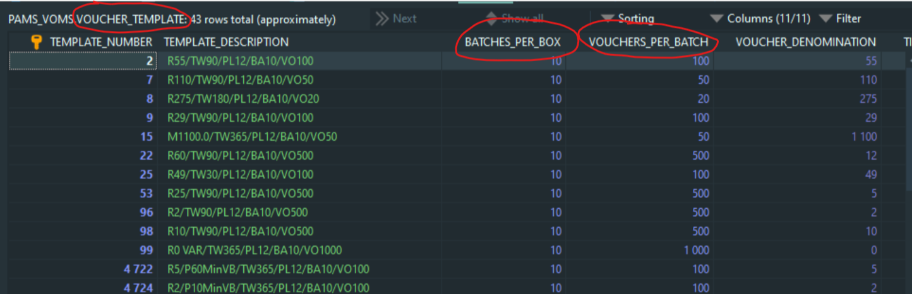

Note that the **template_number** and **voucher_type** may not necessarily be the same. To check the mapping between the 2, see attached doc: “Vobill_VOMS requirements_22 04 2020 “

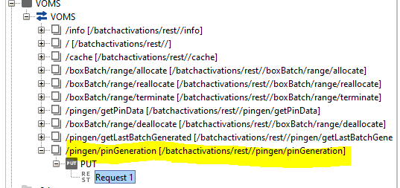

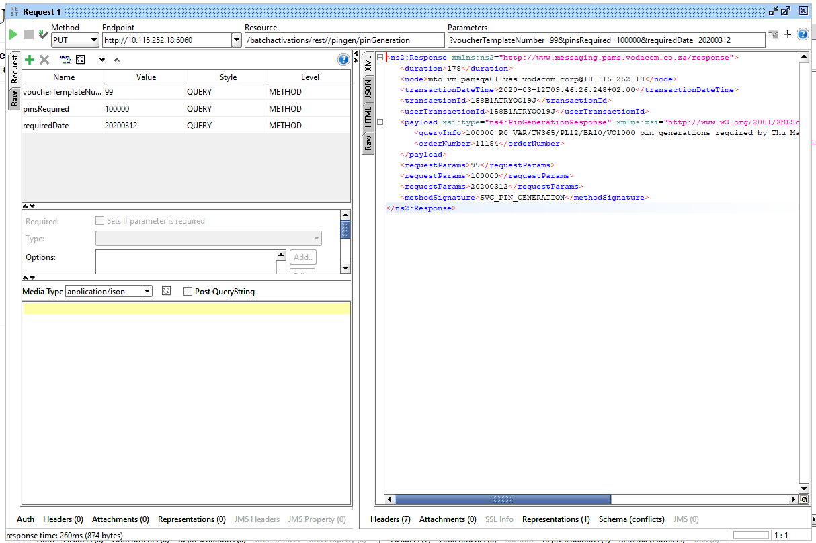

1. Get the Box/batch numbers. There are two options
   1. Check the PAMS database in the table “VOUCHER_ORDER_BOX_NUMBER”; or
   2. Use SOAP/REST interface to get last Batch generated (and then query that batch to get the box number

Example for 2.1

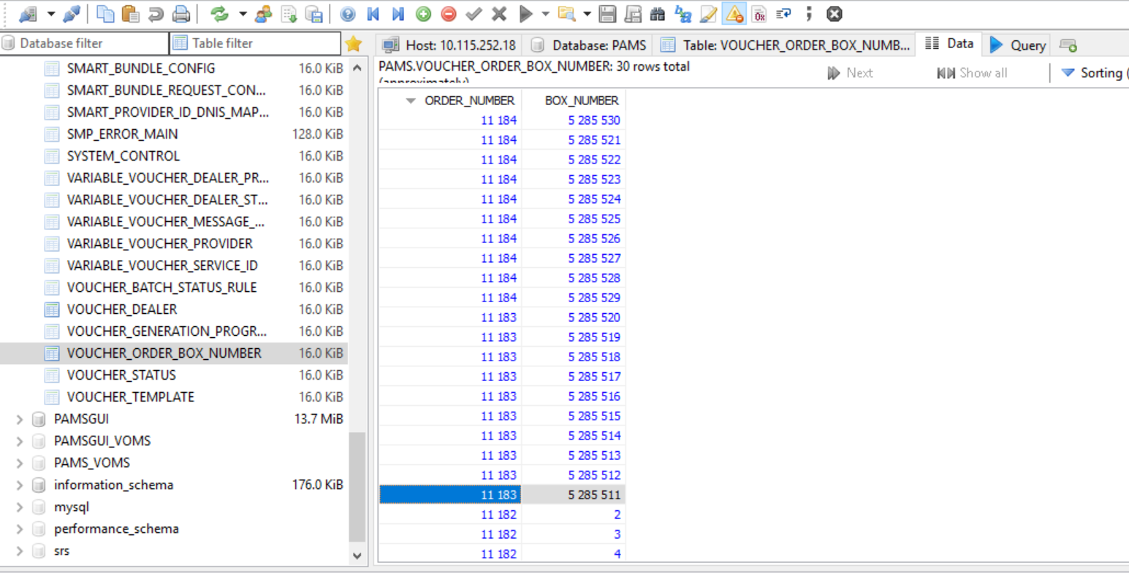

Example for 2.2

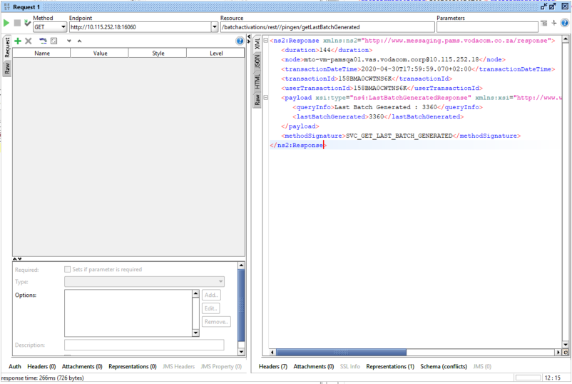

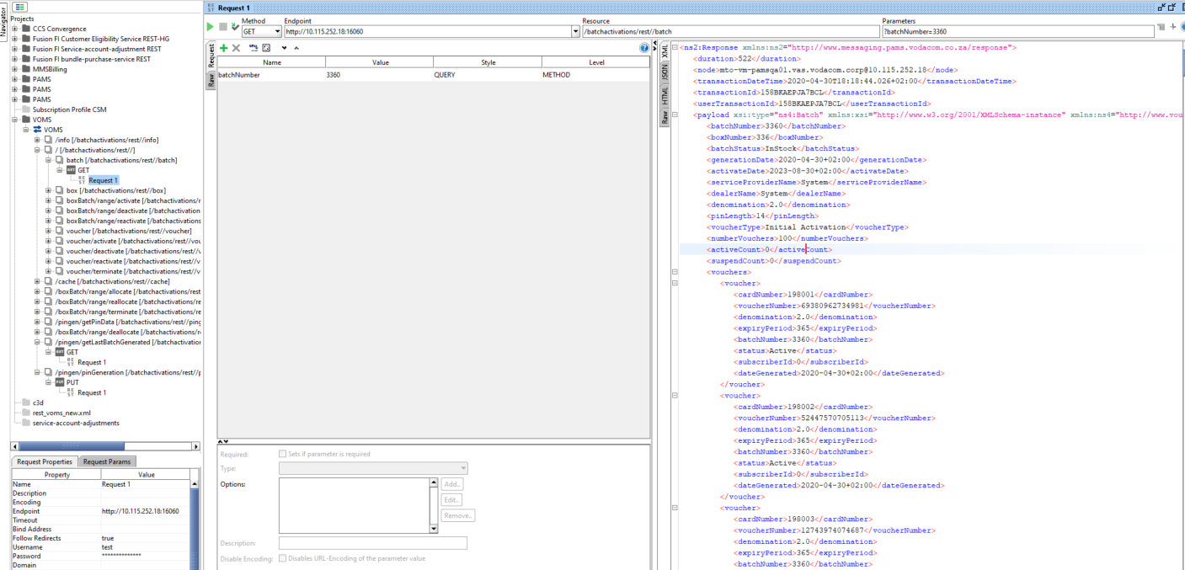

1. **Allocate** the box/batch using **correct voucher type.** This can be done via the GUI or via PAMS SOAP/REST interface

For GUI:

Service provider & Dealer = “Vodacom Internal”

For SOAP/REST

Service provider = 1 & Dealer = 1

For other SPs/dealers, make sure that the Service Provider and Dealer are linked on PAMS. Check tables: BATCH_USER_SP_DEALER_CODE_LINK, SERVICEP_DEALER_LINK, ERVICE_PROVIDER, VOUCHER_DEALER

### BOX AND BATCH RANGE RULES

|  |  |  |  |  |
| --- | --- | --- | --- | --- |
| **Start Box** | **End Box** | **Start Batch** | **End Batch** | **Comments** |
| 1000 | 0 | 0 | 0 | Box Number 1000 will be allocated |
| 0 | 1010 | 0 | 0 | This request is invalid. The start box **must** **always** be entered. |
| 1000 | 1010 | 0 | 0 | Box Numbers 1000 unto and including 1010 will be allocated. |
| 1000 | 0 | 500000 | 0 | Batch Number 500000 will be allocated. (Assuming that batch number 500000 is associated with box number 1000) |
| 1000 |  | 500000 | 500010 | Batch Numbers 500000 unto and including 500010 will be allocated. (Assuming that these batch numbers are associated to box number 1000) |
| 1000 | 1010 | 500000 | 0 | This request is invalid. RMS has no idea which voucher stock to allocate. |
| 0 | 0 | 500000 |  | This request is invalid. The start box **must** **always** be entered. |

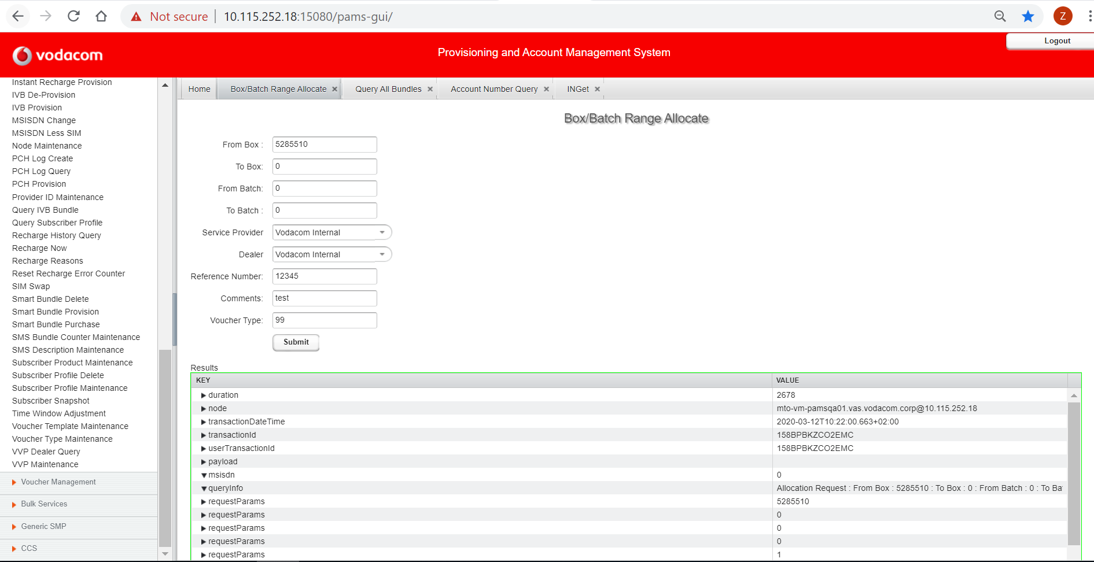

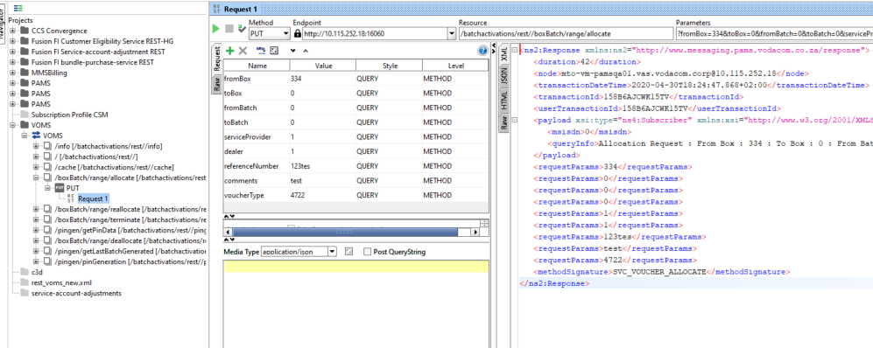

1. **Activate** the box/batch using either GUI or PAMS SOAP/REST interface

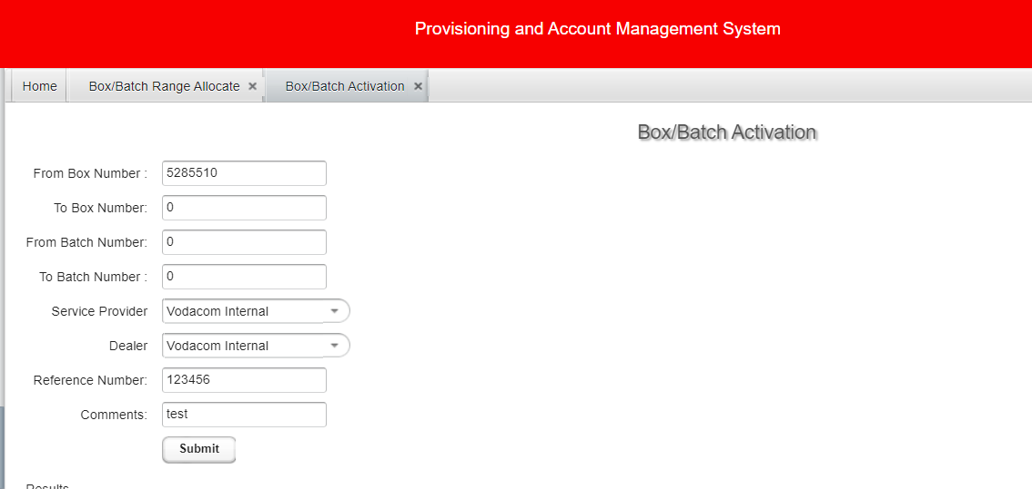

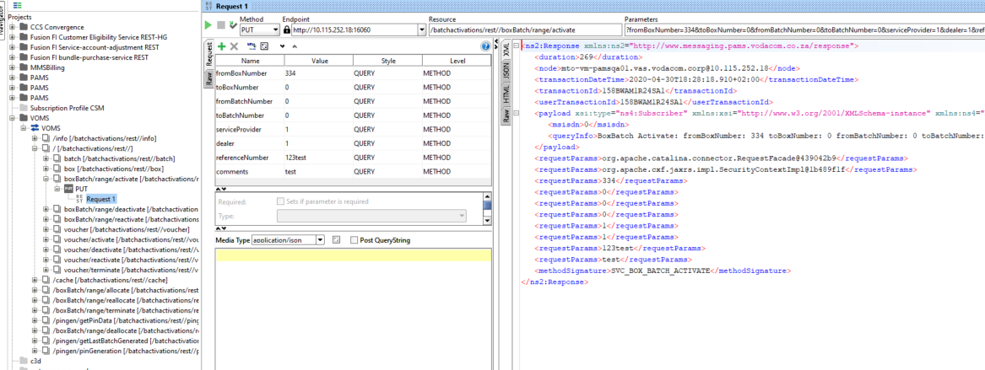

1. Query the Box to get a list of batches. The batches should have status as activated

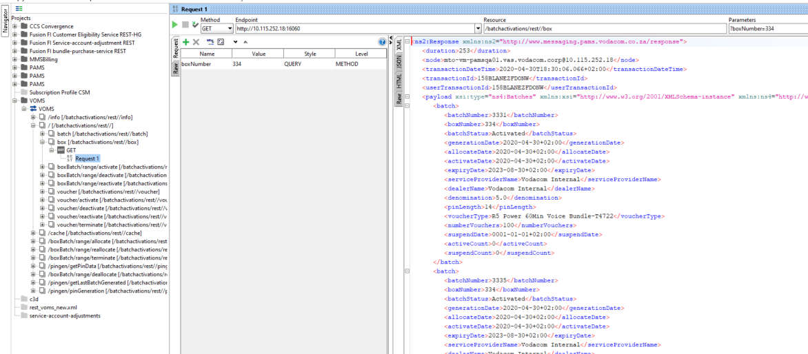

1. Query the Batch to get the voucher pins

